Task1:

The first task was a bit easy, just duplicate the code and alter the array until you get what you want.

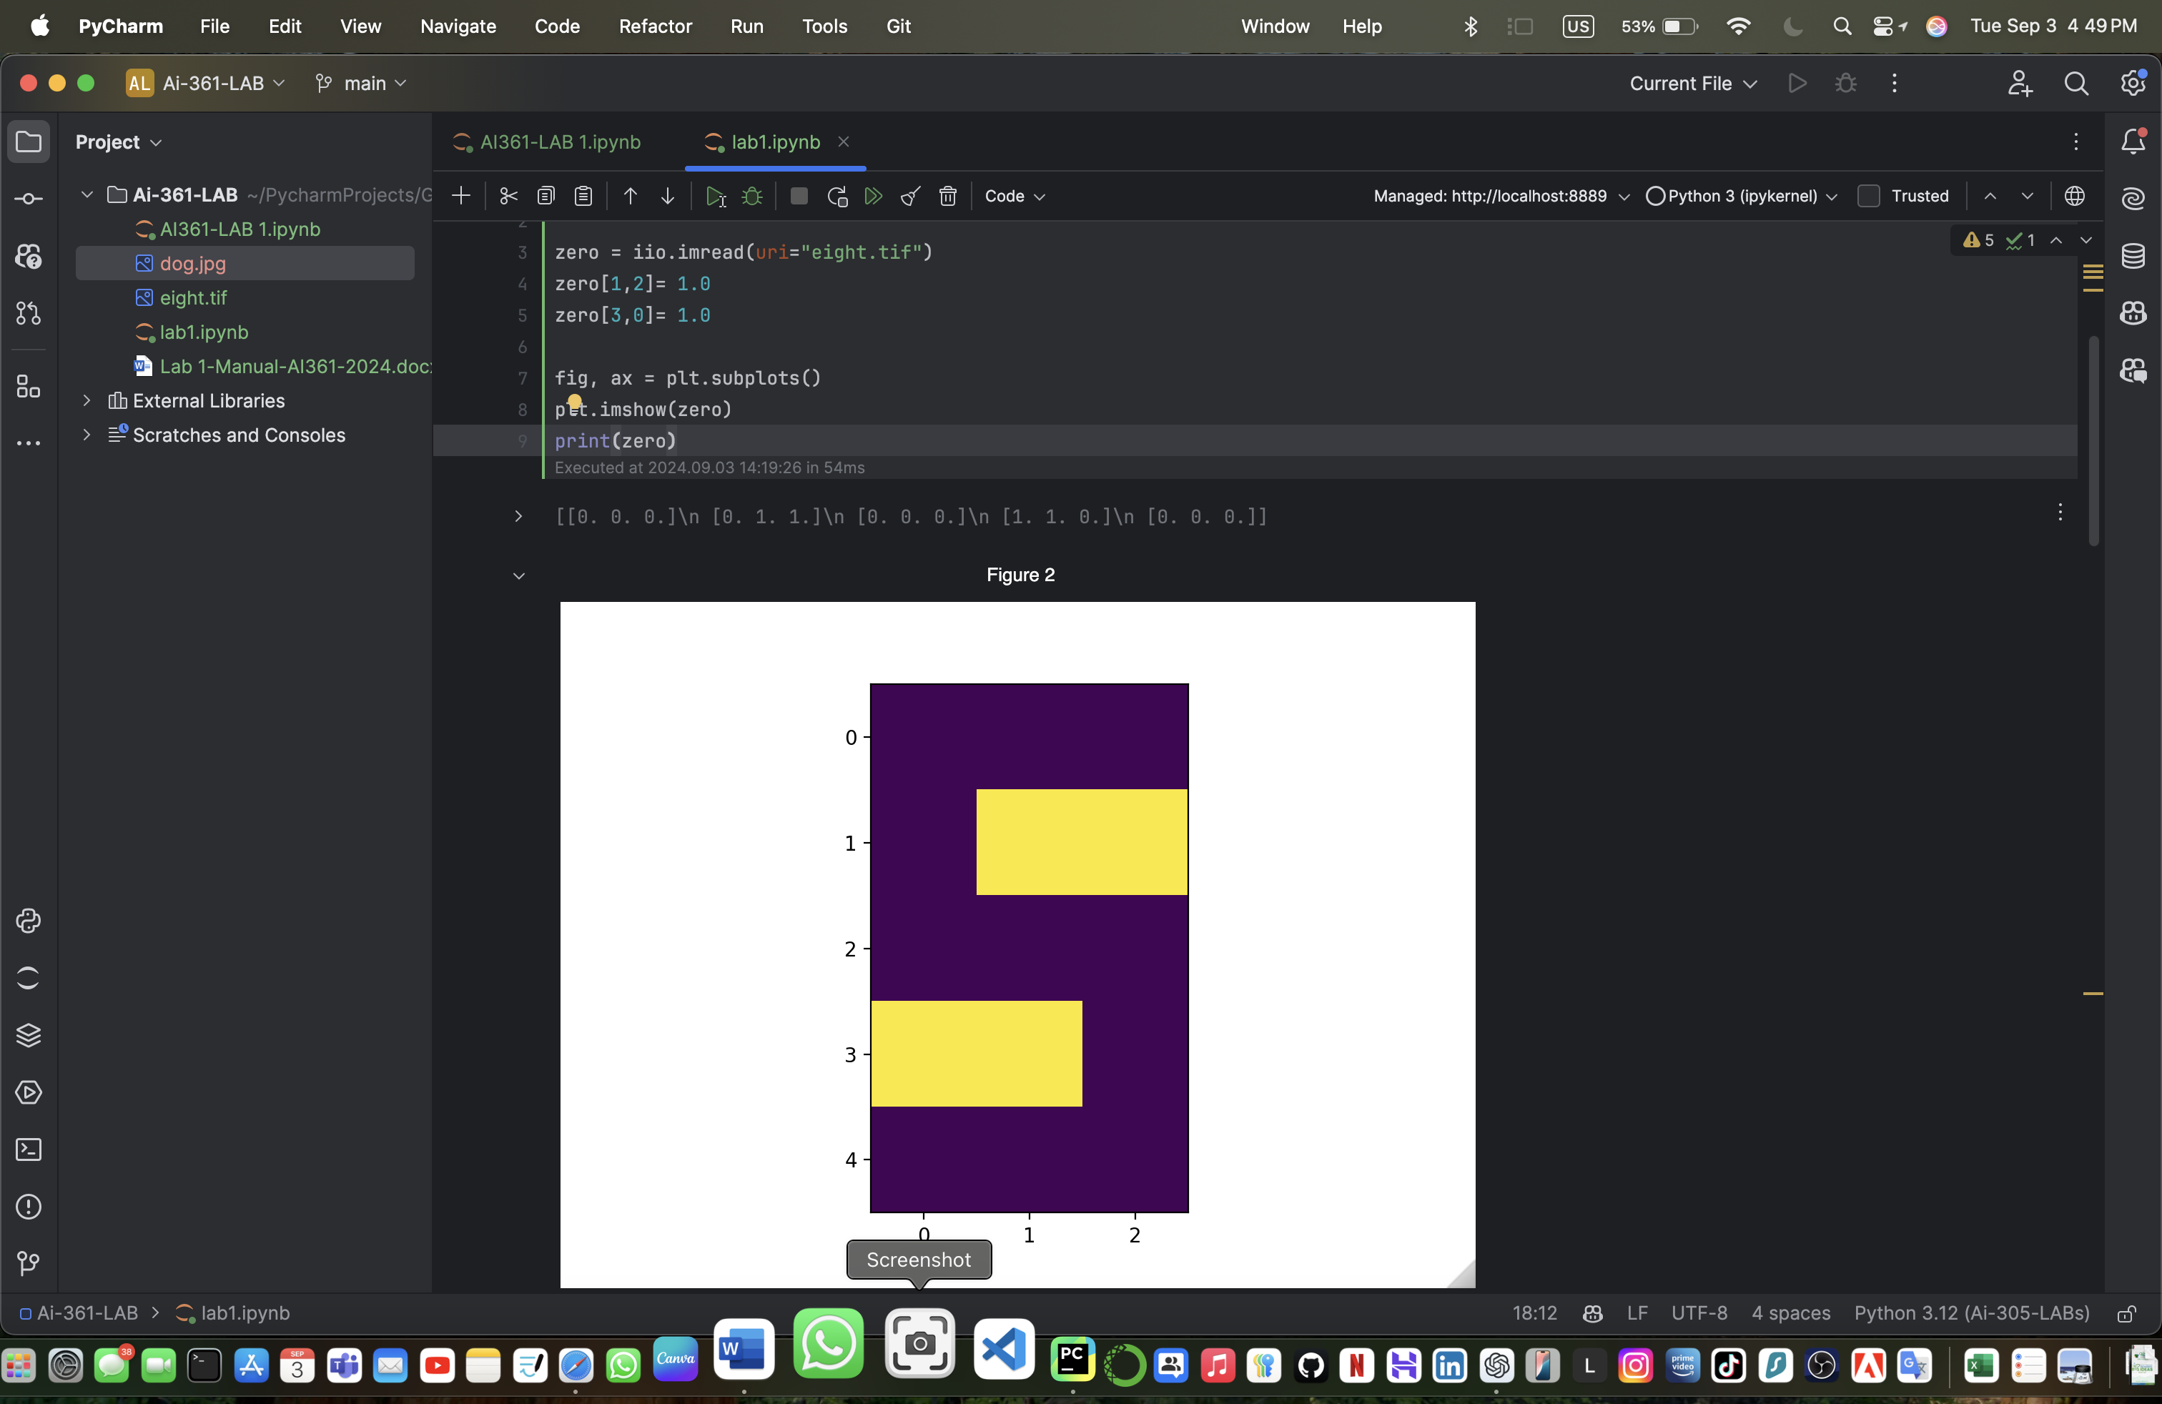

Task2:

This task is a bit challenging because This code lets you change part of an image's color and save it. First, you type in the location of the image file on your computer. Then, you type a number between 0 and 255 to decide how much of the blue color you want in the image (this number affects the blue channel of the image). The code opens and shows you the original image. After that, it goes through every pixel (tiny dot) in the image and changes the blue color to the number you picked. Once it finishes, it shows you the new image with the adjusted blue color. Finally, it asks you were to save this new image and saves it for you. A message pops up to confirm that the image was saved successfully.

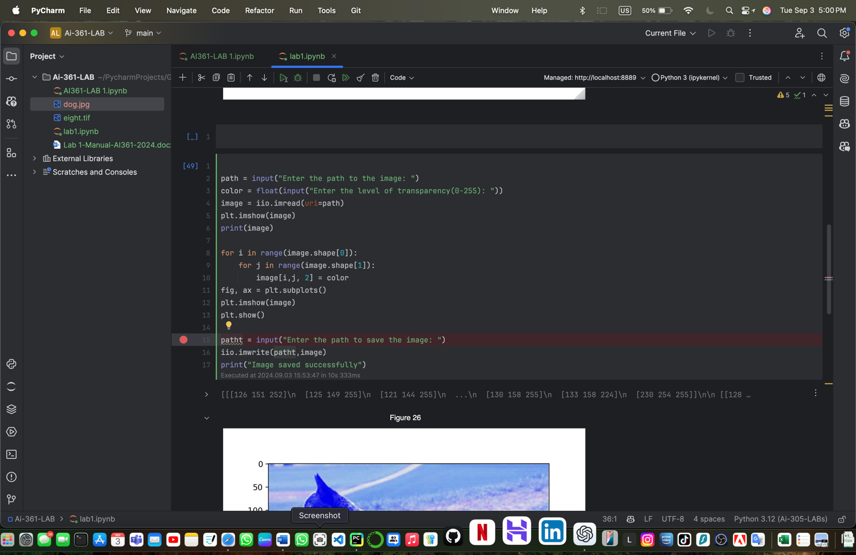

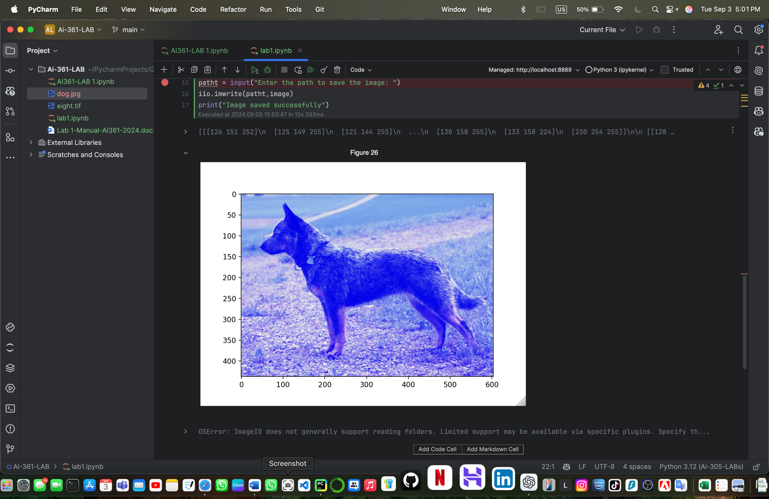

Declaration:

I have use ChatGPT to debug only one problem I got with a module and I saw my error and understand what went wrong.

